Setup a wireless router

While LinkIt Smart 7688 development board is in AP mode, its Wi-Fi and Ethernet interfaces both act as LAN ports. This enables to connect to the board for system configuration. It's possible to configure the Ethernet interface operating on LAN port to act as a WAN port. Therefore, the LinkIt Smart 7688 development board becomes a wireless router when it's still in AP mode.

Prerequisites
- Breakout boards with an Ethernet port. For example, Seeed Studio provides Breakout for LinkIt Smart 7688 and Arduino Breakout for LinkIt Smart 7688 Duo.
- An Ethernet cable.
- A router with Internet connection.
- Set the LinkIt Smart 7688 development board to the AP mode.

Step-by-step
- Connect the LinkIt Smart 7688 development board with the breakout board.
- Connect the router with Internet connection to the breakout board through an Ethernet cable.
- Power on the board.
- Sign-in to the Web UI.
- Go to OpenWrt's Web UI through the link below the Sign out.
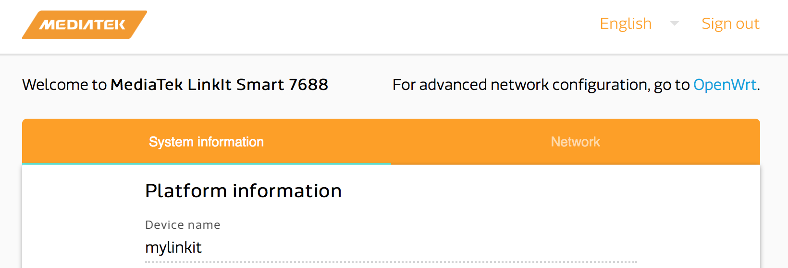
- Sign in the OpenWrt's Web UI with the root password.
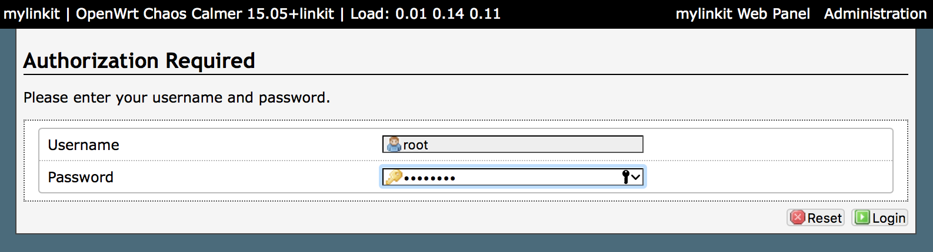
- Select the Network tab.
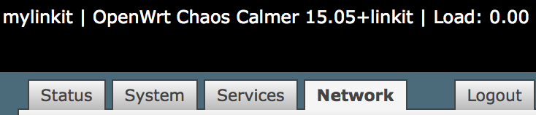
- Click Edit under Actions for the WAN network on the Interfaces page.
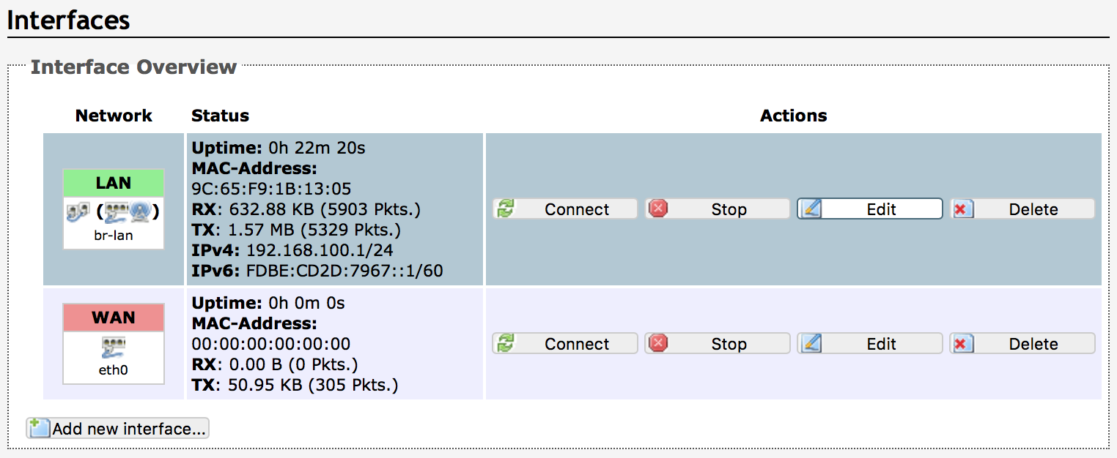
- In the Common Configuration page of the WAN interface, select Physical Settings.
- Check the Ethernet Switch: "eth0" option.
- Click Save & Apply to start the configuration.
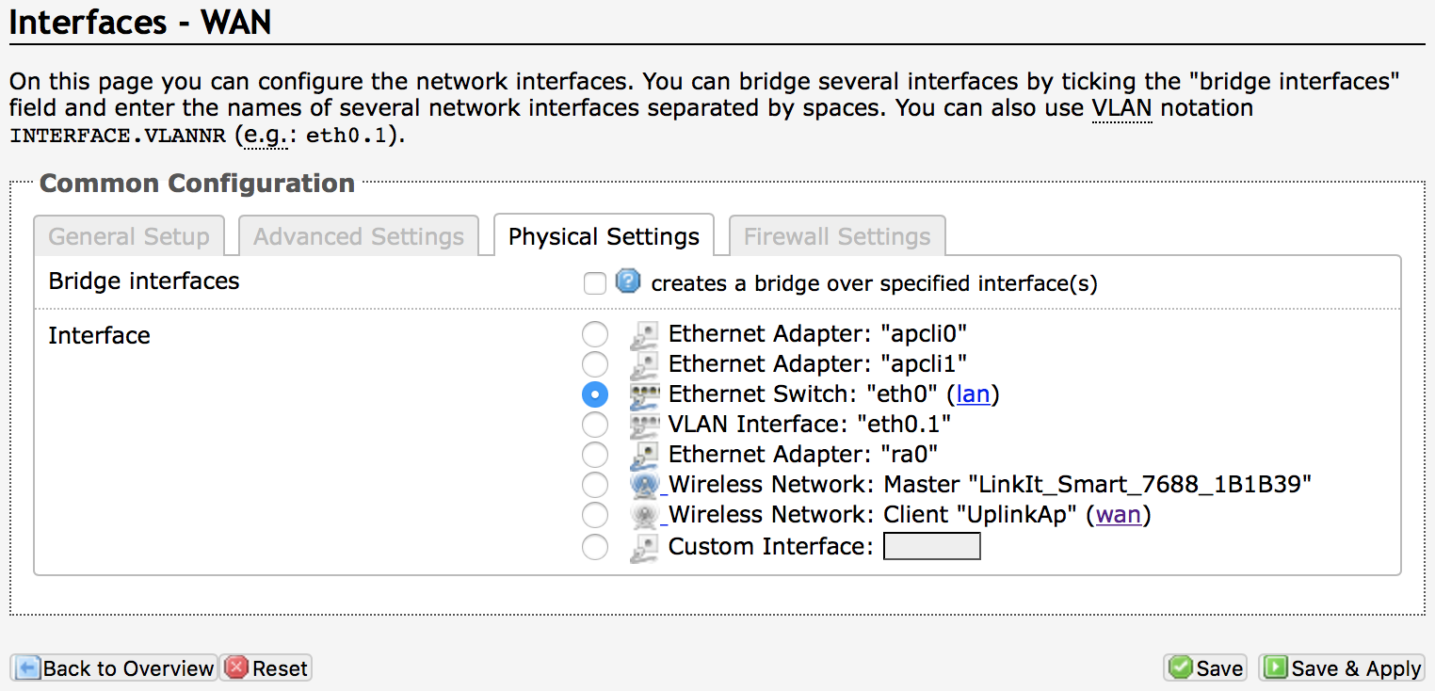
- Once the configuration is complete, it'll return to the Interfaces page.
- Click Edit under Actions for the button in the LAN network.
- In the Common Configuration page of the LAN interface, select the Physical Settings .
- Uncheck the creates a bridge over specified interface(s) option.
- Click Save & Apply to start the configuration.
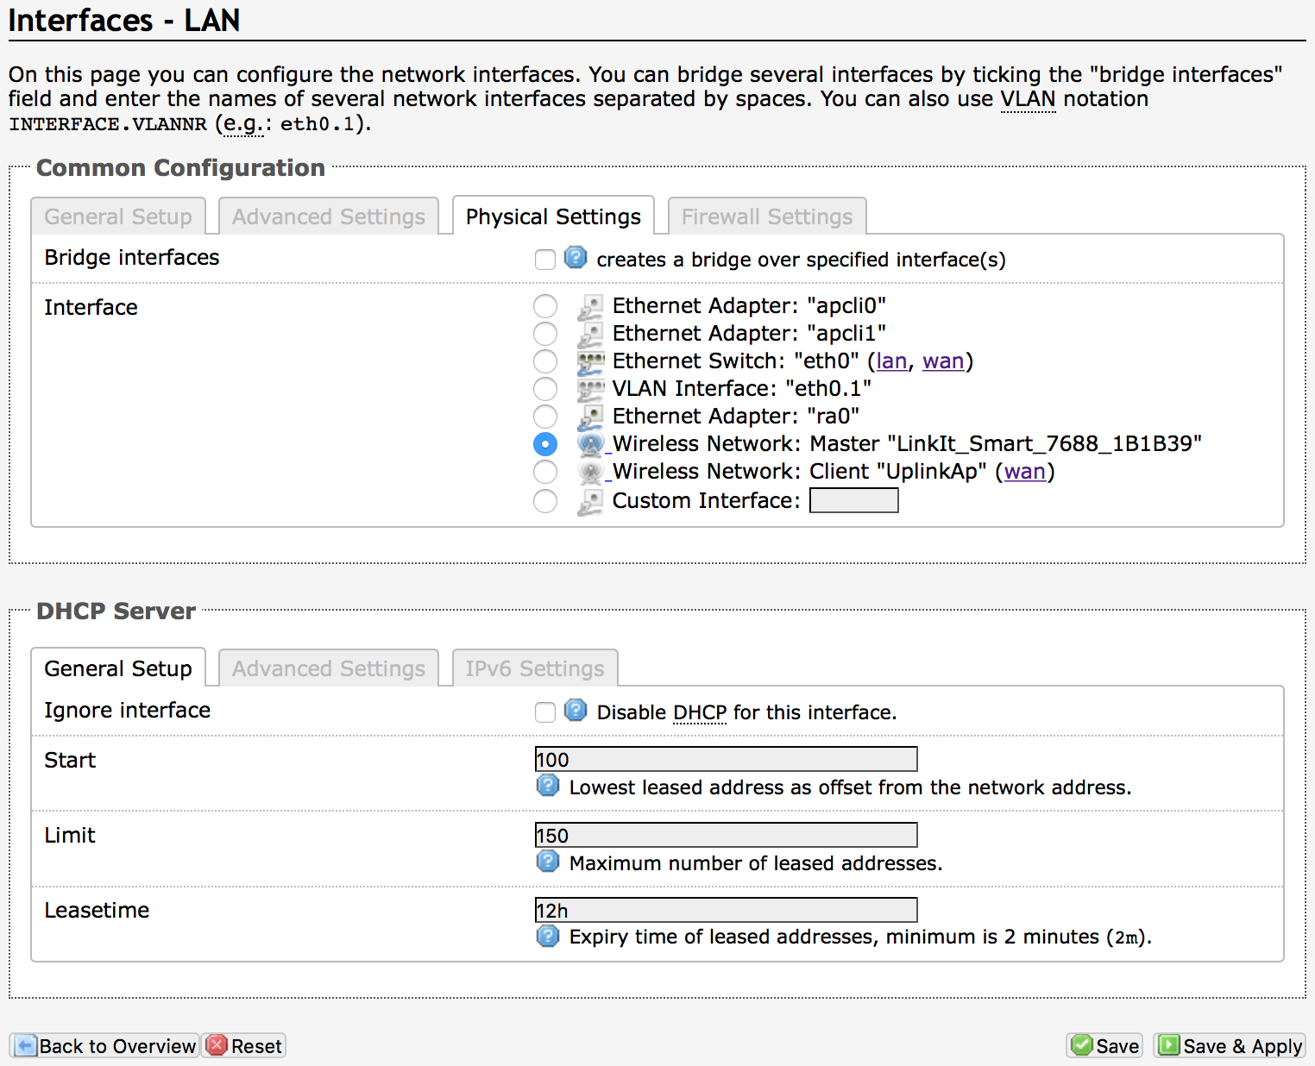
- Once the configuration is complete, it'll return to the Interfaces, as shown below.
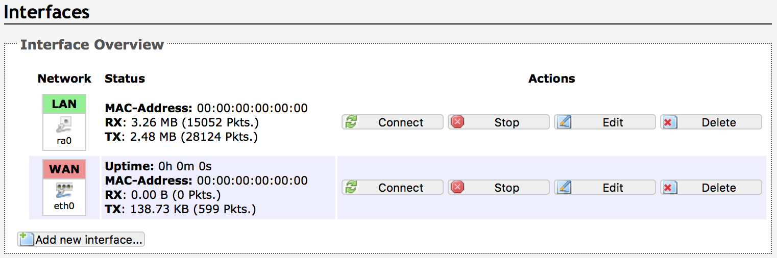
- Reboot the device and wait for the system to boot up.
- You've now successfully configured the board (see Wi-Fi LED states). The LinkIt Smart 7688 development board can now be used as a wireless router to access the Internet.

DNS setup
To customize the DNS settings and the domain search option for the LAN port, you can edit /etc/config/dhcp by adding two parameters ( domain and dhcp_option ) as follows. In this example, we assume the DNS is 172.20.70.10 and the search domain is mediatek.inc :
config dnsmasq
...
option domain 'mediatek.inc'
...

config dhcp 'lan'
...
list 'dhcp_option' '6,172.20.70.10'
...
Note
Number 6 before the DNS ('6,172.20.70.10') means the following value is used for assigning the domain name server. Please refer to OpenWrt's Wiki for detailed configurations.

